**Ex:** 10

**Date:** 20/11/2020

**Aim:**

To write a Python function that accepts a string and calculate the number of upper case letters and lower case letters .

**Program:**

def string_test(s):

d={"UPPER_CASE":0,"LOWER_CASE":0}

for n in s:

if n.isupper():

d["UPPER_CASE"]+=1

elif n.islower():

d["LOWER_CASE"]+=1

else:

pass

print ("Orignal String:",s)

print("No. of upper case characters:",d["UPPER_CASE"])

print("No. of lower case characters:",d["LOWER_CASE"])

s=input()

string_test(s)

**Output:**

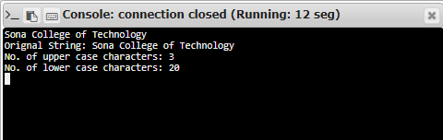

**Result:**

Thus, Creating python function find number of upper and lower case of characters in a string is done.

**Link:**

<http://103.53.53.18/mod/vpl/forms/submissionview.php?id=325&userid=1652>